Federated insurance : system update

04/15/2019

Keerthana Sadasivan, Joseph Dosch, Peter Fischbach, Matthew Young, Sneha Shakya

**TABLE OF CONTENTS**

1 Letter of introuduction 3

2 team description 4

3 description of customer/client 5

4 System request form created by team 6

5 fact-finding preparation 6

6 results of fact-finding 9

7 Project scope and recommendations 11

8 project schedule 13

9 feasibility analysis 15

11 data flow diagram legend 16

12 data flow diagrams 17

13 decomposition diagrams 18

14 data dictionary 19

15entity relationship diagram 26

16 crud matrix 27

17 user interface mockups 28

18 user role descriptions and security authorizations 31

19 appendix : resumes 32

**Letter of Introduction**

Dear Valuable Customer,

We are here as a group speaking to our task Federated MVR and we are happy to do this project demonstrating our capacity to perform. We wish to take a couple of minutes to present ourselves as the individuals from Federated MVR. Working for this association is a dream come true and it is with most extreme satisfaction to work on this project.

We hope to create a database for you that would be more beneficial for your company. Customer satisfaction is what’s most important to us. If at any point do you not see what we see, please make sure to tell us. We are here to help you build the future you wish to see for your company. We are all about providing the highest quality of work and we promise to leave you with a more efficient MVR system.

Within several weeks, we will be conducting interviews with a lot of you with the sole purpose of getting to know your company better. We not only want to know the current state of things but also what could or should be done. We appreciate any feedback that ensures that we translate your business goals into our successful IT projects and our success is measured purely based on your satisfaction with our system.

Please be free to reach to any of our team members

Here are the emails you can reach:

Sneha Shakya: [sneha.shakya@mnsu.edu](mailto:sneha.shakya@mnsu.edu)

Joseph Dosch: [joseph.dosch@mnsu.edu](mailto:joseph.dosch@mnsu.edu)

Peter Fischbach: [peter.fischbach@mnsu.edu](mailto:peter.fischbach@mnsu.edu)

Matthew Young: [matthew.young@mnsu.edu](mailto:matthew.young@mnsu.edu)

Keerthana Sadasivan: [Keerthana.sadasivan@mnsu.edu](mailto:Keerthana.sadasivan@mnsu.edu)

**TEAM DESCRIPTION**



**Joe Dosch**

**Project Manager**

Manages project resources and assigns roles depending on time and scope.

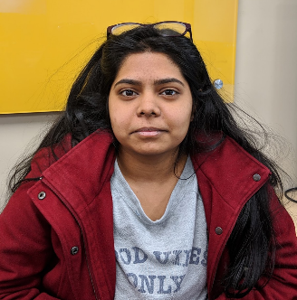

**Keerthana Sadasivan**

**Database Administrator**

Oversees data insertion, updates, and deletions.

.



**Matthew Young**

**Project Manager**

Manages project resources and assigns roles depending on time and scope.

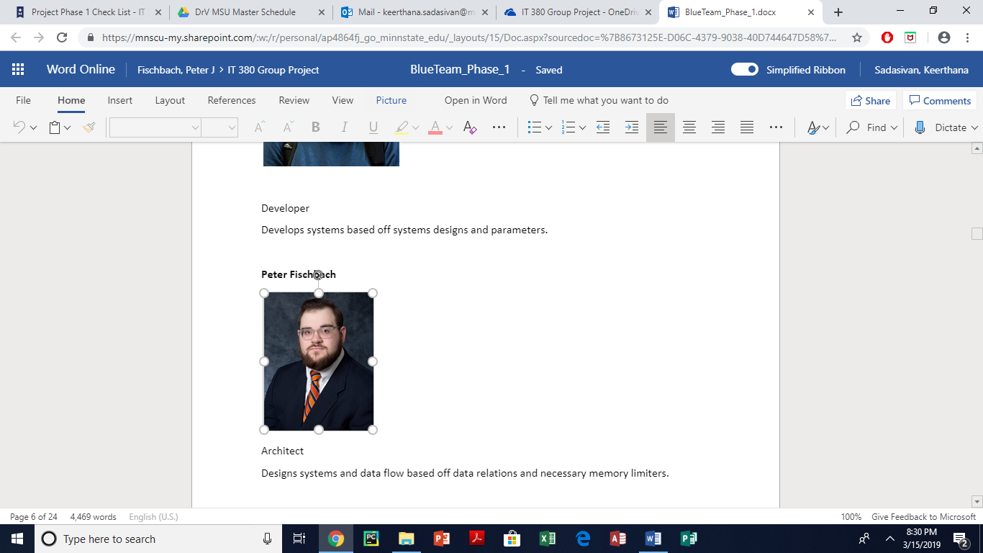

**Peter Fischbach**

**Architect**

Designs systems and data flow based off data relations and necessary memory limiters.



**Sneha Shakya**

**Analyst**

Processes and manipulates data built in to systems.

**Description of Client/Customer**

Federated Insurance is a mutual insurance company that started in Owatonna, Minnesota and expanded to the point that it now serves customers throughout the nation. Their mission, taken from their website, is “As a mutual insurance company, we believe our value is measured by the success of our clients”. A mutual insurance company is a company where the people who have ownership in the company are the people who hold the policies, so profits made by the company are distributed back to the policy holders.

As far as people who will be using the system, that will most often be people dealing directly with clients, either ones assigned specifically to them, or in a broader term for higher-ranking employees. One position, known as the underwriter, will use this system to analyze a Motor Vehicle Report (MVR) and make assessments based on risks while driving and will decide insurance rates and premiums based on those risks. A processor is the person who will decide when and how often to order those MVRs based on when a driver from a perspective client is analyzed. A customer (meaning a company, not a specific employee) can also request and view MVRs to look at which employees have more risks associated with them, and to see if there could be one specific cause for things like premiums going up.

The system we create must be accessible and make sense to anybody who may work on it, from people very familiar with the industry, like underwriters or processors. But it also must make sense to “laypeople”, like customers who may not always know the ins and outs of the industry. When it comes to a company like Federated, there may be lots of underwriters per branch. It will be important to make sure that all of them can easily adapt to the system, whether they are newer employees or not.  Also, processors often only work in one state, so making sure the system works as a generic database is key, making sure we can adapt to any state necessary. It also needs to be very secure, as an MVR is not available to the general public at will and must be requested. Since the state and/or federal government also can have access to MVRs, that makes it more important for our system to be secure.

**System Request Form Created By Team**

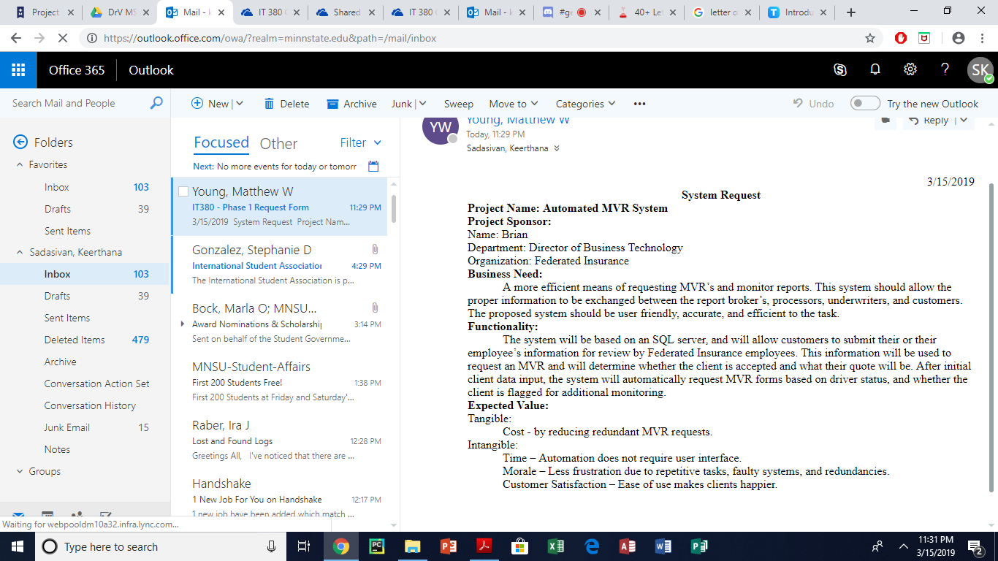

**Fact-Finding Preparation**

**The following survey will be sent out to all employees that will work with the database.**

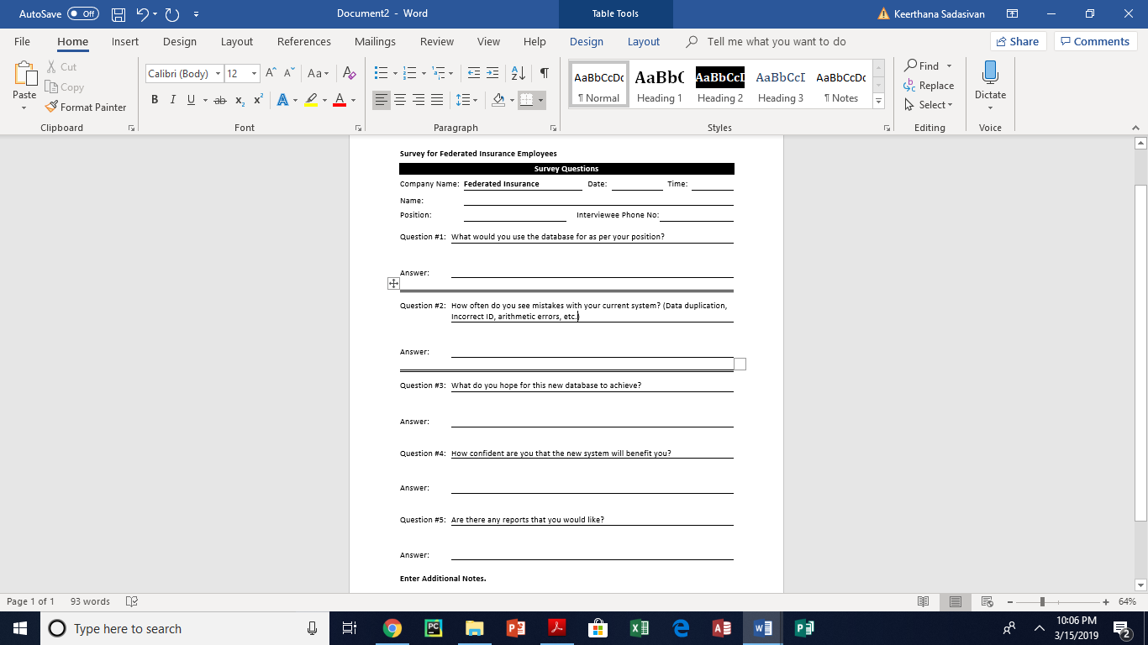

**An interview will take place and cover the following content and the compiled list of questions.**

We would conduct interviews with employees from at least one representative for each division of the company. Even though, they will not all be using the MVR, it’s good to know their perspective as well and think about the company. To begin with, we would have to interview the processor and underwriter to extract as much information as possible since they will be a huge part of this MVR system. It would also be better if we were to observe them for a day to see how they do their job so we have a better understanding of how they request MVR’s and the information they key in. We would have to talk to the Information Technology department to see what systems they are currently using and their technology to make sure it can support our system. We would also have to talk to the security team to see who can have what access and to determine to administrative controls that would have to be placed.  In addition to all this, it would also be ideal to speak to the HR team to see how they would evaluate the overall performance of the company once the MVR system is launched. In the case of an interview with at least one representation from each decision, below is a list of questions we would ask and who it would be directed at.

In addition to an interview, we would like to request the following system documentation to get a better understanding of your current system. We would like actual copies of forms and operating documents currently in use at Federated. Please remember to submit both blank copies of forms and actual completed forms. We would also like the documentation of any software packages they use.

**Compiled Questions:**

|  |  |
| --- | --- |
| Questions | Directed At |
| Should we record any change to the database separately for documentation? | Underwriter, Processor |
| What reports do we need to generate? | Underwriter, Processor |
| Who are the key roles in this MVR system? | Underwriter, Processor |
| Who needs what access? | IT Security, Underwriter, Processor |
| How are your currently managing all the data in your company? | Underwriter, Processor, Risk Management |
| What business process or service is the database going to cover? | Underwriter, Processor, Risk Management |
| Do you want all your customer’s data combined for all services (from life insurance to business insurance)? | Underwriter, Processor, Risk Management |
| Is there any changes that you see in the near future that should also be incorporated in the database? | Underwriter, Processor, Risk Management |
| When do you need the database created by? | Underwriter, Processor, Risk Management |
| What are the main benefits that you expect from this database? | Underwriter, Processor, Risk Management |
| What is the biggest issue that needs to be taken care of in day-to-day operations? | Underwriter, Processor |
| Aside from storing data, what are these databases used for? | Risk Management, Customer Service, Underwriter, Processor |
| How many people work with the database daily, and what are some examples of specific jobs associated with those people? | Risk Management, Customer Service, Underwriter, Processor |
| How often does data redundancy happen and how long does it take for people to notice? | Underwriter, Processor |
| How do processes for database management differ from department to department in the MVR system? | Risk Management, Customer Service, Underwriter, Processor |
| Are there any additional functions that you would like to request? | Risk Management, Customer Service, Underwriter, Processor |
| What systems does the software need to be compatible with? | IT |
| Which members will be championing the project? | Risk Management, Underwriter, Processor |
| Should there be more focus on GUI or raw functionality? | Risk Management, Underwriter, Processor |
| How refined should the GUI be? | Risk Management, Underwriter, Processor |
| What security do you want implemented in the software? | IT Security |
| What administrative controls would you like implemented? | IT Security |
| Have there been any major changes in your business in the past year? | Risk Management, Underwriter, Processor |
| How many ways do you record data? (Paper/electronic) | Risk Management, Underwriter, Processor |
| How much do you see your business expanding in the future? | Risk Management, Underwriter, Processor, Sales, Customer Service |
| How do you keep track of the details of your clients currently? | Risk Management, Underwriter, Processor |
| What are the most common ways you use your data? | Risk Management, Underwriter, Processor |
| What are some things you would like to use your data for that you cannot do now? | Risk Management, Underwriter, Processor |

**RESULTS OF FACT-FINDING**

This system we are trying to build will automatically order MVRs and monitor the drivers. In the current system, they were manually ordering the MVRs and monitoring the drivers. The MVR report is ordered by the insurance companies to identify drivers with unsafe driving records. This will help them determine if the company wants to insure them. In some cases, they can turn the customer down if the probability of an accident is very high.

In order to get an MVR report on a driver, the **insurance company must pay anywhere between $6-$10 to brokers like IIX or Choice Point** .It’s only 6 cents for monitoring violation. However, the report will only say if there was any new violation or not. If the report says that there was no new violation, we can ignore it. If it says there was a new violation, we would have to pay the $6-$10 and order a full report again.  This is important because ordering a MVR is cheaper than an accident. Keep in the mind that we would need the company to upload their driver’s license and list of drivers.

It’s important that the company keys in this information. In order to get a MVR, the **insurance company would need their driver’s full name (First Name, Last Name, Middle Name or Initial) and license number.**  **One account number can have multiple policies**connected to it .We also must make sure to **store the customer’s relationship and they can only have one type of relationship.**They can either be the owner, family member, heavy truck driver, all other frequent users and all others infrequent users. **If they’re an owner, order MVR every year**. **If they’re a family member, order every three years.** **If they’re a heavy truck driver, order every year**. **For all other frequent users, the MVR must be ordered every year and for infrequent users, the MVR must be ordered every three years.** We should also have the **option to change the frequency** for somebody that’s considered suspect.   
  
We should also be able to keep track of how often you send the person’s name in and if they got it back or not. **The processors type in the information**, and the **system raises a flag** when there is a violation. The processor does data entry. **If we don’t get a no hit or an error, they will get the message coming back.** They will also **ignore the ones with no violations**. And **if they come back with a violation, processors give the MVR to the underwriter**. **Underwriters decide on whether to insure them, put them on probationary, or exclude them**. From this system, the underwriter would need to be able to get enough information in order to decide.    
  
The **deliverables** of the system include **receiving the MVR, assessing a driver, and ordering the MVR**. The clients need to be able to fill out an application. The system monitors for violations and uploads information for a new perspective drive. It needs to be able to **print reports for the risk management team**. Some of the reports would be the frequency somebody has had a violation in a given time or the highest type of violations whether it be a DUI or an accident. The risk management team should have access to view and print the reports mentioned above.  For this system, there are no significant hardware-related concerns now, but all systems must be capable of running Windows 7 at minimum, with Windows 10 being the recommended operating system.

**PROJECT SCOPE AND RECOMMENDATIONS**

Out of scope

* Determining cost and the time the project will take.
* Analyzing payment records and flagging late payments.
* A system that decides if a customer should be considered a liability (this should be decided by the underwriter.

In scope

* A web-based interface that allows customers to apply for insurance, access their accounts and file claims.
* Customers will be able to fill out a form that records their information and details about what information was accessed or updated.
* Customer applications will be added to a list of new customers and be sued for a request for their MVR.
* Customer applications and MVR will be recorded for future business purposes.
* A system that analyzes new customers
* The system will collect information from new customers by asking the customer to fill out a form containing their personal information.
* The system will analyze the MVR of new customers.
* The system will record any violations the customer has previously had and information about the violation.
* The ability of the system to request an MVR
* The system should request an MVR after a period depending on the type of driver.
* Backups will be accessible to those with necessary security credentials.
* Information will be automatically backed up.
* The MVR of Frequent drivers is requested more often than non-frequent drivers.
* A feature in the system will automatically request an MVR for a driver depending on the type of driver they are.
* Ability of the system to analyze updates and MVR’s from vendors
* The system should have the ability to analyze number of violations in updates.
* System should be able to attribute violations to specific vendors.
* The system should be able to recognize and document personal information in the MVR.
* The ability of the system to maintain and edit a list of drivers.
* Active drivers or frequent drivers.
* Inactive or infrequent drivers.

* The security of the system
* Granting and analyzing user permissions.
* The system will analyze user permissions and restrict or allow access to information accordingly.
* Processors and underwrites have shared access to some information.
* Severely limiting access to information to those outside of Federated Insurance.
* The ability for MVR’s to be delegated only to employees that are on a need to know basis.
* Recording information collected by Federated Insurance to assist with future business operations
* MVR’s, employee data, customer information and access records will be backed up and secured.
* Creation of a system that assists employees by providing relevant information
* The system will analyze driving records and supply underwriters with information analyzed from the MVR.
* Information from the MVR will be secured and only sent to the necessary employees.
* The system will use information collected from MVR that pertain to information the underwriter needs to know.
* The system will include relevant information about employees that accessed the data.

**Actions to be taken**

Prepare an analysis of costs and benefits so that management can decide if IT systems and computing infrastructure upgrades are financially worthwhile.

Devise ways to add new functionality to existing computer systems.

Design and implement new systems by choosing and configuring hardware and software.

Oversee the installation and configuration of new systems to customize them for the organization.

Train the systems’ end users and write instruction manuals.

**PROJECT SCHEDULE**

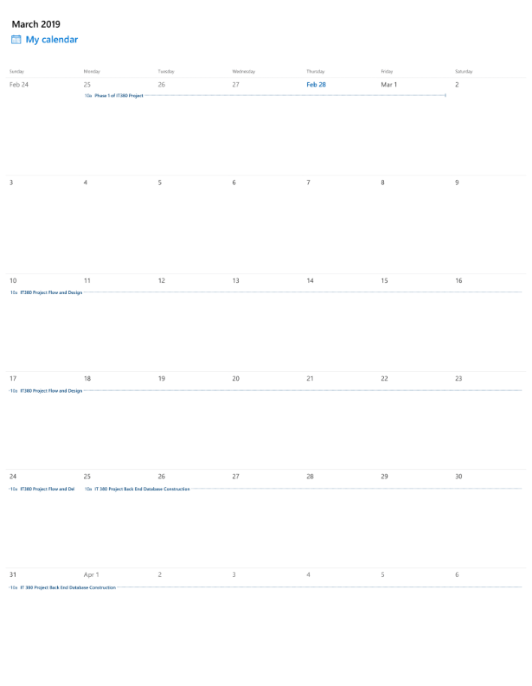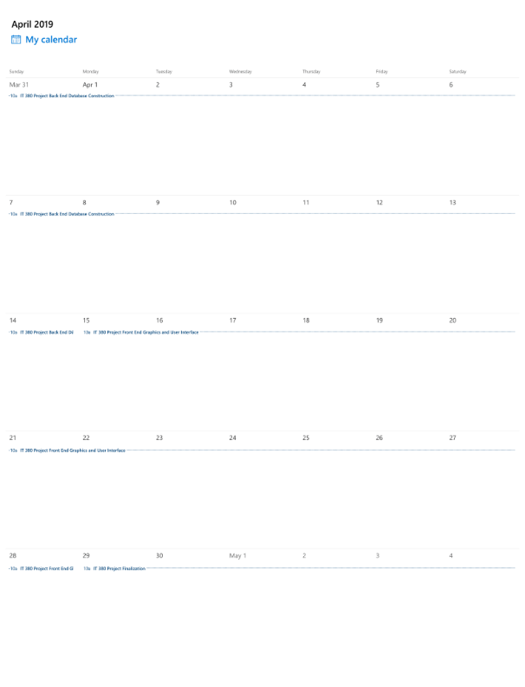

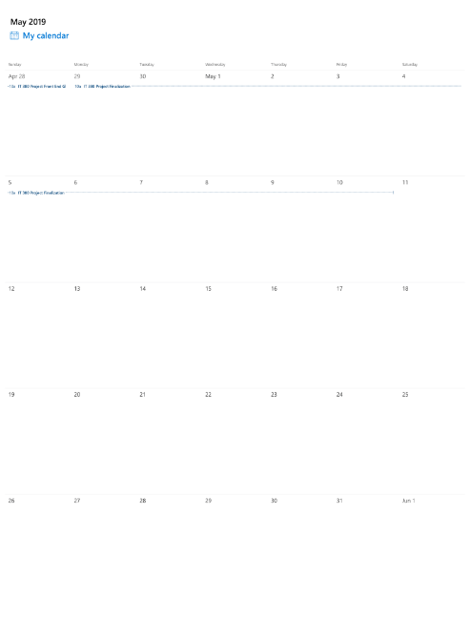

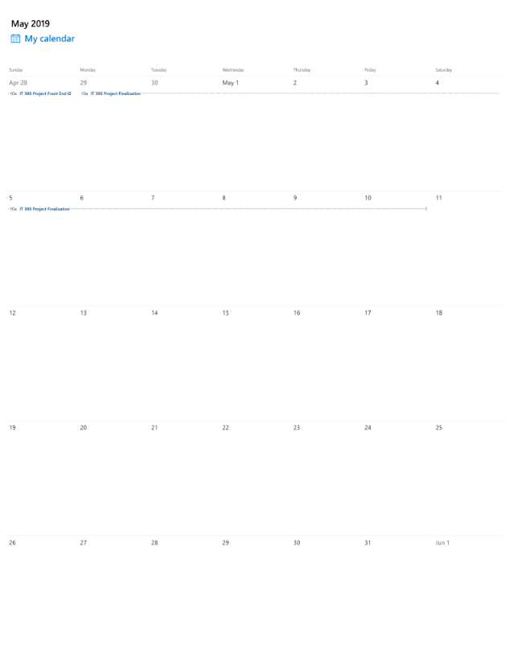

**FEASIBILITY ANALYSIS  
  
Operational Feasibility –**

* Our user interface design allows for ease of access and understanding for the end users in the system.
* The system requires minimal user input, thus alleviating as much frustration and potential for human error as possible.
* Overall operational feasibility is solid and practical.

**Technical Feasibility –**

* Federated Insurance already has the bulk of the infrastructure required to run our MVR system including server systems and database software.
* The network setup is easily configurable with systems already present, they just need to be expanded.
* All in all, the system is technically feasible.

**Economic Feasibility –**

* Initial cost of hardware setup should ballpark $50k-$60k.
* Ongoing maintenance for this system will be around $60k yearly for the first three years to help iron out any bugs, afterwards cost per year will drop dramatically.
* Tangible ROI will be a 75% reduction in time expenditure, a rise in work efficiency by 60%, and will eliminate redundant MVR requests saving $5 per request.
* Intangible ROI will be an increase in user satisfaction and employee morale.

**Scheduling Feasibility –**

* Phase 1 planning was completed on March 15, 2019
* Phase 2 designing is to be completed on April 15, 2019
* Project will be finalized on April 29, 2019

**Data Flow Diagram Legend**

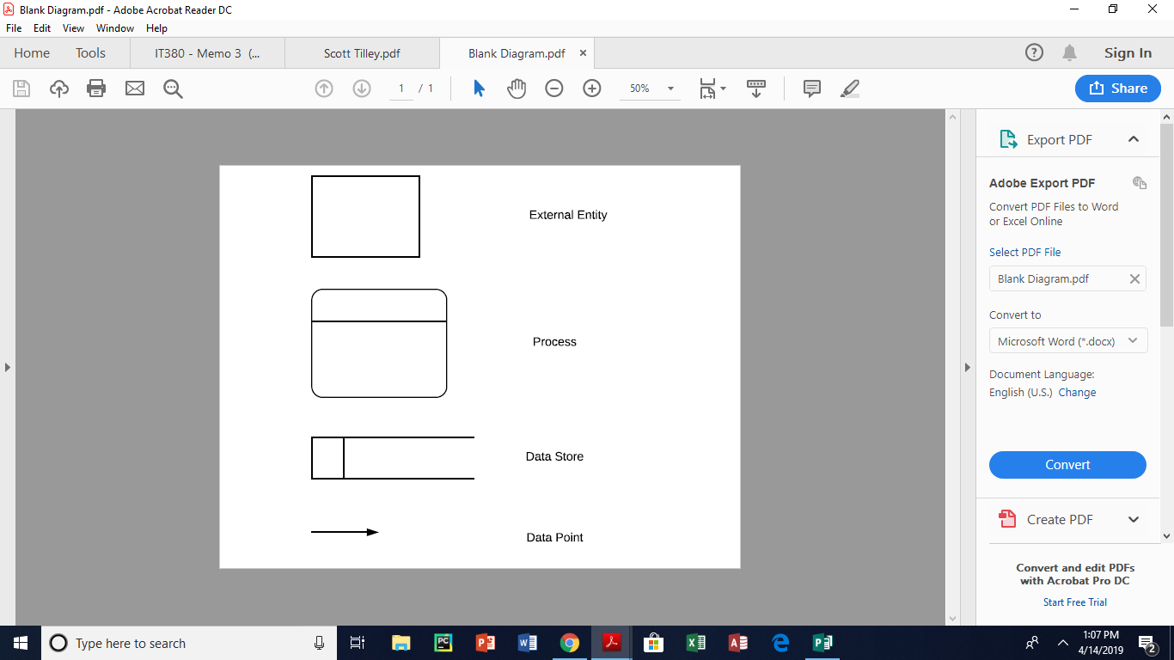

**Data Flow Diagram**

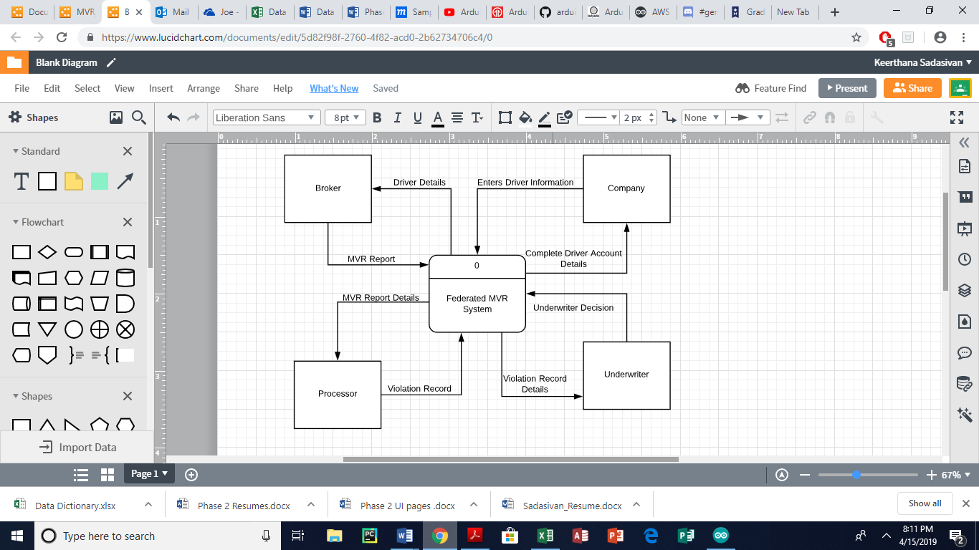

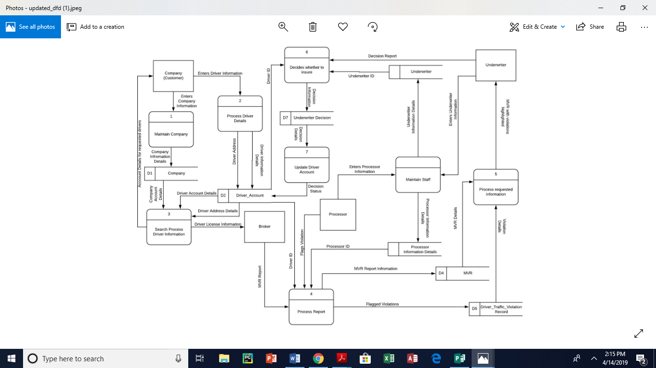

**Decomposition Diagram**

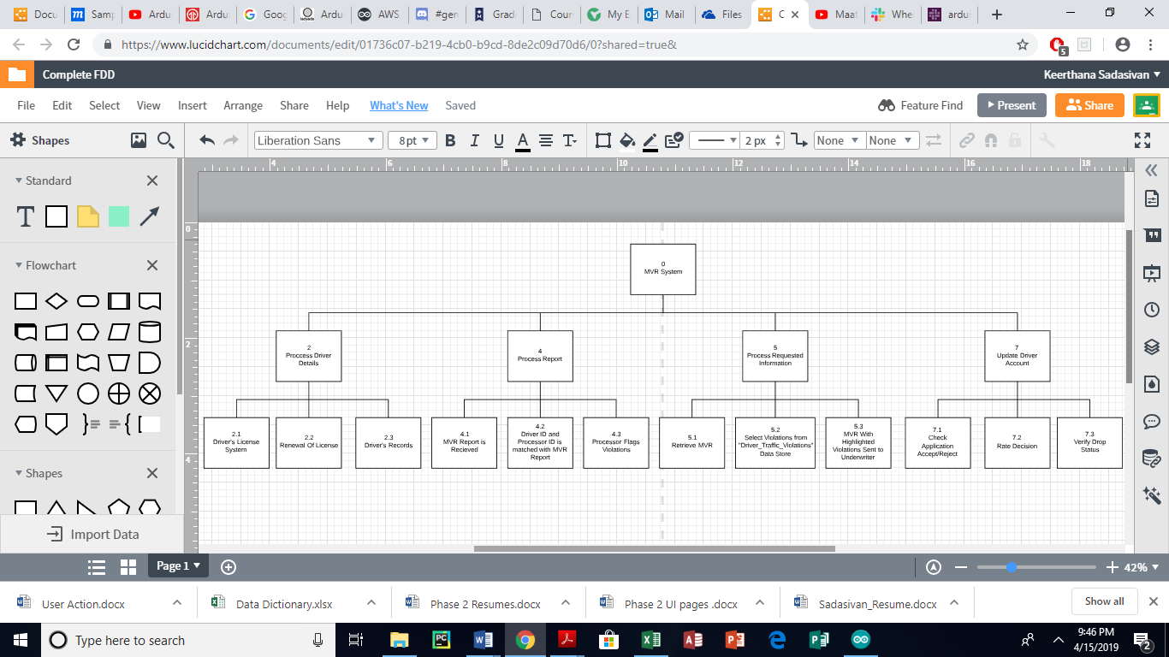

**Data Dictionary**

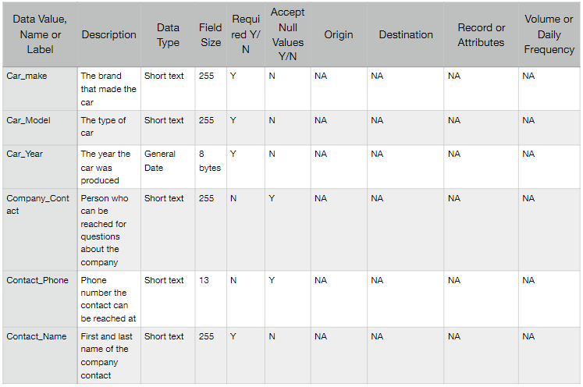

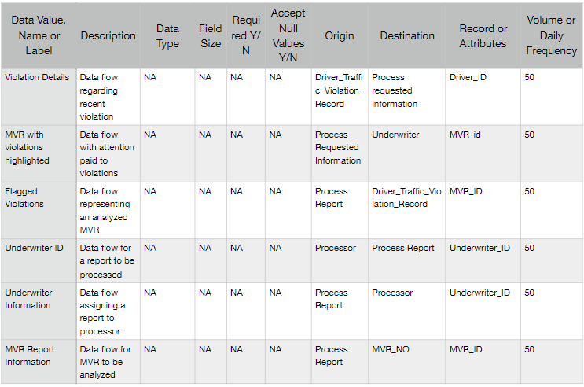**Entity Relationship Diagram**

**Crud Matrix**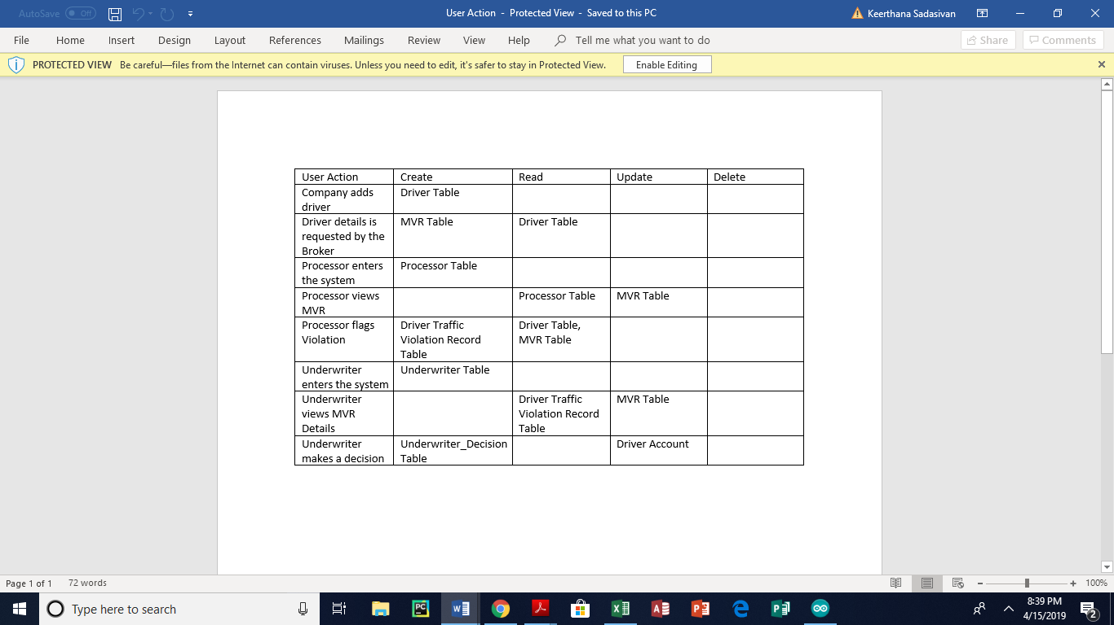

**User Interface Mockups**

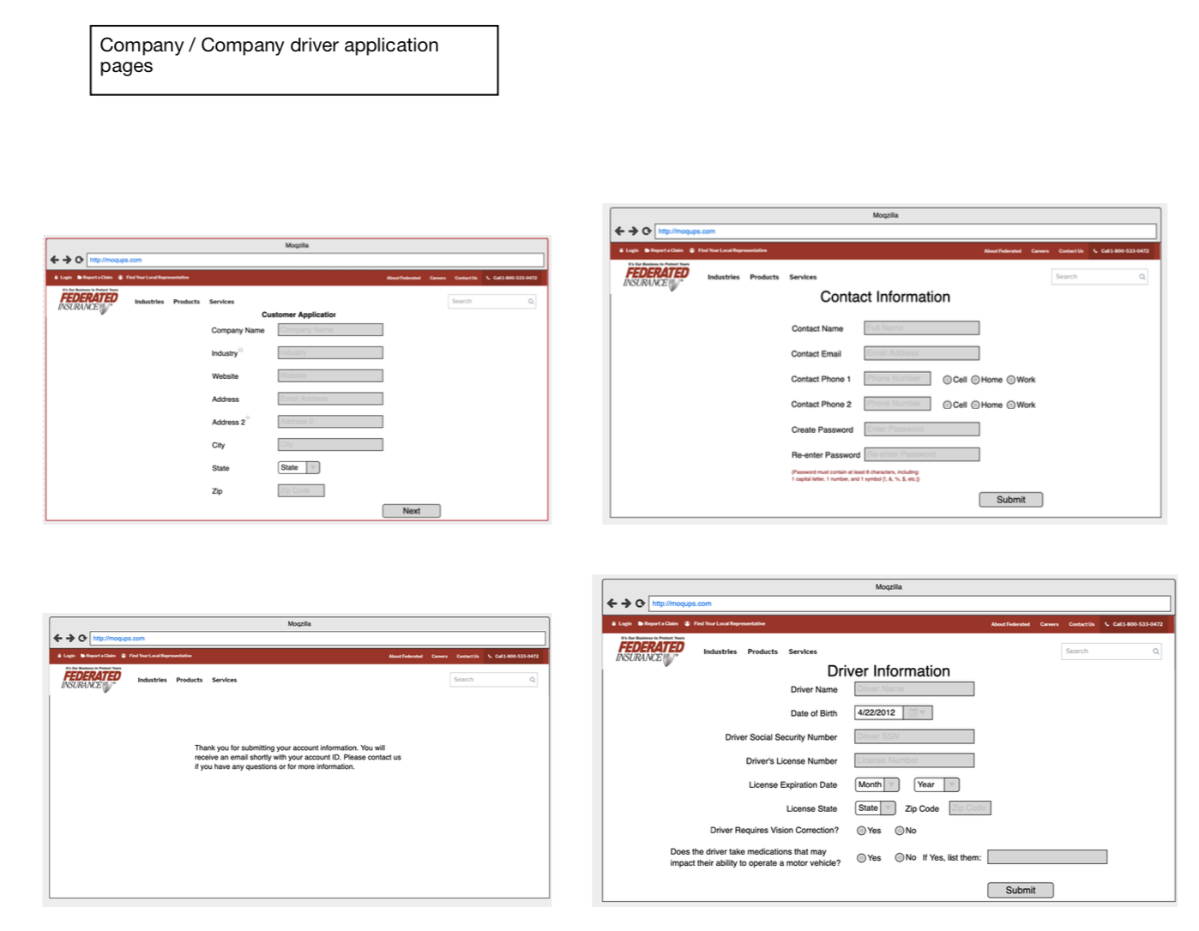

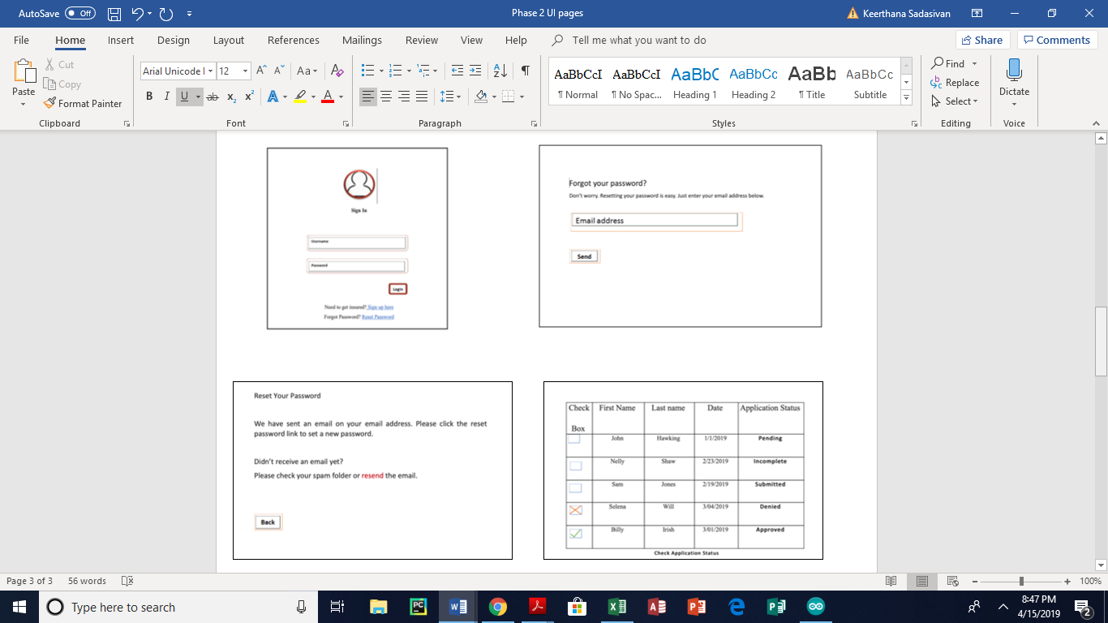

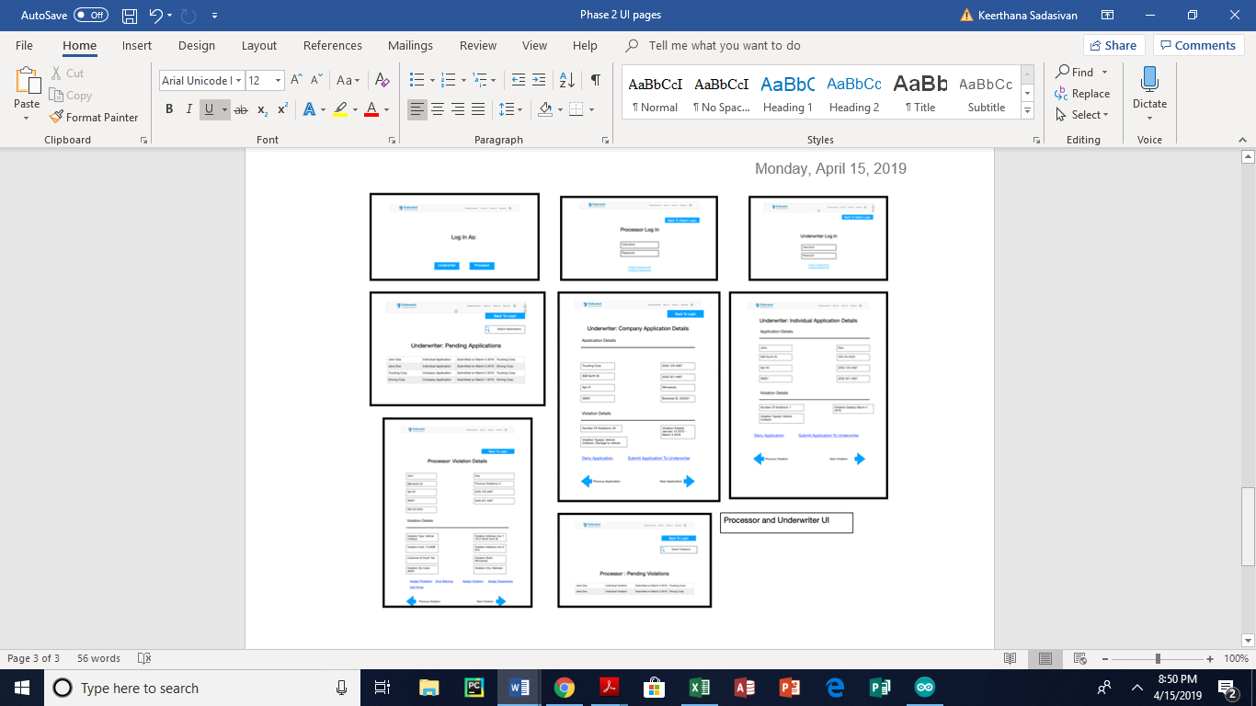

**End User Roles and Permissions**

Since there will be four main users for this new automated MVR system, careful thought must be put into the security of both the front and back end users of the system. Especially when it comes to user roles and viewing permissions. In addition to standardized login and password system and administrative database controls, user roles and viewing restrictions on certain sets of data are crucial in making sure that the system is not allowed to compromise the individuals, or the companies’ information. In order to achieve this level of security we outlined the roles as follows:

**Company Role –**

Companies can submit driver information for review by the system. Any submission that is still pending review can be edited or updated by the company. The company can only edit, view status, or view submission information for their own associated submissions. To ensure this, each company login is given a unique company id, and each submission includes the company id for it to be associated with the company. Once a submission has been reviewed and either accepted or rejected by the system it is no longer available to be edited or updated but may still be viewed by the company.

**Broker Role –**

Brokers are only allowed to view pending submissions that are completed. They can view these submissions regardless of company or association. The only information from the submissions that they can view are the driver’s license information and submission date. Once an MVR is received for the driver the Broker is no longer allowed view the pending submission for that driver.

**Processor Role –**

Processors can view MVR’s from the Broker and any information on them. Based on the information provided by the MVR the processor can flag any violations presented. Whether the MVR is flagged or not the system then assigns the MVR an underwriter id for use later.

**Underwriter Role –**

Underwriters can view all currently flagged MVR’s marked with their underwriter id, as well as whether the driver submission is currently pending. If the driver submission is pending, the underwriter decides on whether to accept or reject the driver as well as what their rate will be if accepted. If the driver submission is not pending, the underwriter determines the action that needs to be applied to the driver’s current rate, should the rate be increased, left alone, or the driver should be dropped.

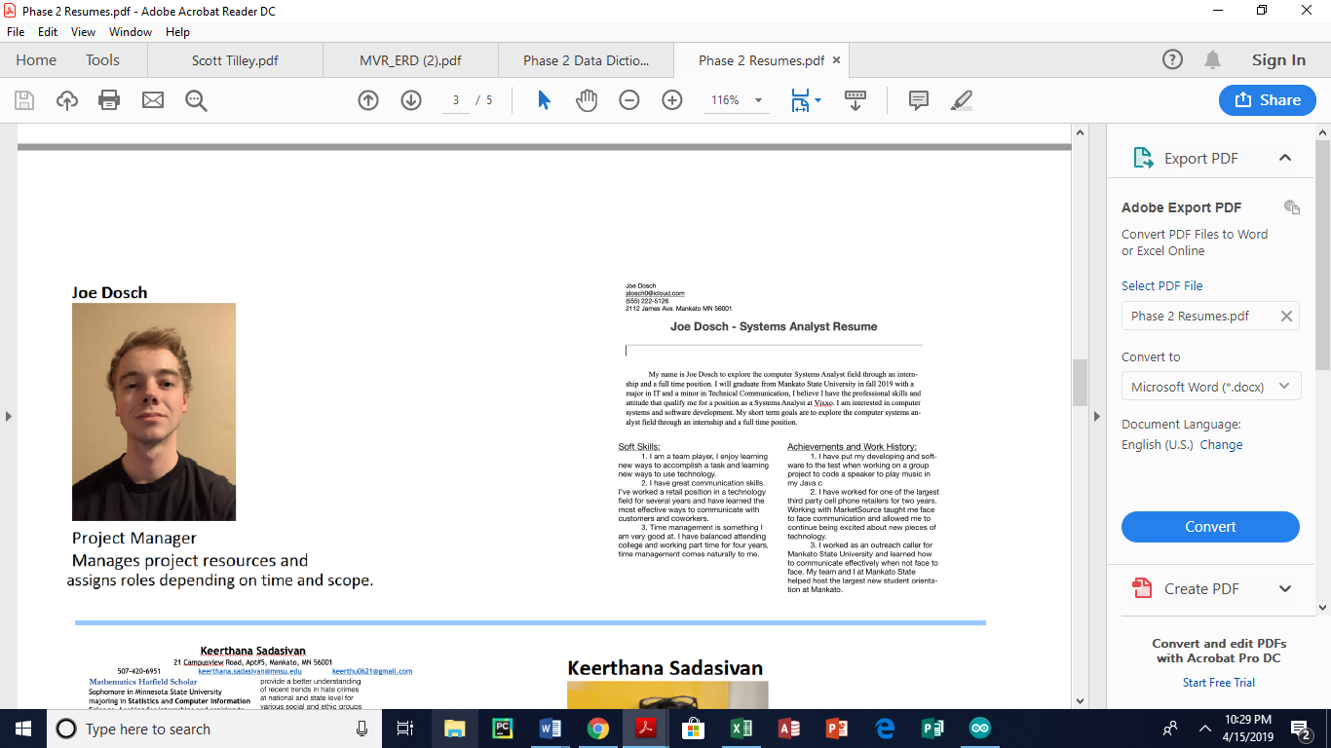 **Appendix**

